Saga Beta 2 Launch Set For December 11th
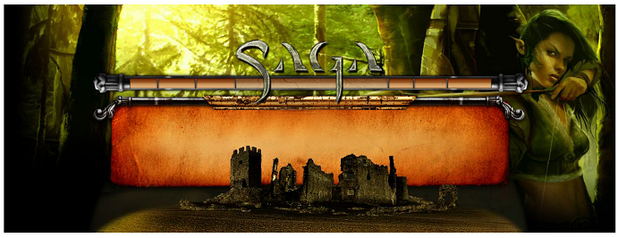

Released on: December 3, 2007, 10:03 pm
Press Release Author: Silverlode Interactive
Industry: Internet & Online
Press Release Summary: Saga, a new Massively-Multiplayer Online Real-Time Strategy (MMORTS) game from Silverlode Interactive announces December 11th for its final Beta phase.
Press Release Body: Silverlode Interactive today locked in December 11th as the start of their final Beta. Players who joined in the Phase 1 Beta test will be the first to gain entry; others will be admitted on a first-come first-served basis. In addition, Silverlode Interactive is working with game and hobby shops across the U.S. and game review websites worldwide to distribute Beta keys good for priority entry into Beta.
Saga Beta 2 will release many anxiously awaited features over the course of the phase. Here’s a few: The initial screens and user interface have been improved and completely rebuilt in an easy and intuitive format. A brand new storyline-based quest system has been added that includes epic boss battles for multiplayer strategy. The chat system has been renovated to enhance trading and guild communication. A tournament system will be introduced later in Beta 2 that allows players to win products as well as increase their ranking. In addition, Saga received a major graphics overhaul making the visuals spectacular.
Silverlode Interactive is distributing preferred Beta keys to local gaming stores across America. Store proprietors may contact the Silverlode Interactive PR department (szatuchny@playsaga.com) to request a Beta display.
Players are currently invited to sign up at www.playsaga.com/signup_beta.php. Visit the Saga main page www.playsaga.com and the Saga forums for updates and latest reviews as well as a video of Saga game-play footage coming later this week.
About Saga – Saga is a persistent world RTS in an epic fantasy setting. Players collect troops, build armies, conquer new lands and build up kingdoms, complete with resource collection, city building and peasant management. Saga’s features include massive armies, multiplayer questing, guild wars, espionage, and an auction house for trading troops and spells.
Saga has no subscription fees. Players pay as little or as much as they decide, by purchasing ‘booster packs’ of random troops and spells, which are traded and customized to create the strategic army of choice for each player. Visit www.playsaga.com
Web Site: http://www.playsaga.com
Contact Details: Slava Zatuchny
Silverlode Interactive
Tel. (617) 905-8482
Email: szatuchny@playsaga.com
URL: www.playsaga.com

