Skeptiko Host, Alex Tsakiris, Responds to Skeptics’ Guide Host, Dr. Steven Novella, and Agrees to Participate in Psychic Medium Research
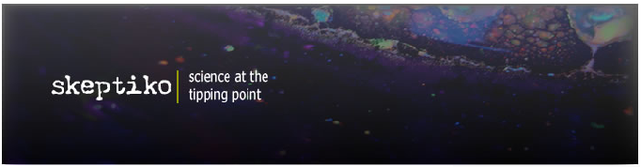

Released on: December 8, 2007, 11:06 am
Press Release Author: Skeptiko
Industry: Education
Press Release Summary: Science philanthropist Alex Tsakiris takes on Skeptic Dr. Steven Novella. In a point-by-point response, Tsakiris claims Novella’s recent Skeptics’ Guide to the Universe broadcast provides further evidence that prominent Skeptics are often severely misinformed about parapsychology and psi researchers like Dr. Dean Radin and Dr. Rupert Sheldrake.
Press Release Body: Join Alex Tsakiris when he responds to claims made by noted Skeptic, Dr. Steven Novella. During the 30-minute show Tsakiris details why allegations of research improprieties against Dr. Dean Radin are untrue, and calls upon Dr. Novella to help correct the situation:
“…Steve got on me for calling Skeptics hypocritical, but I want you to imagine for a minute how Dr. Novella would feel if he spent five years of his life doing meticulous, careful research, publishing in peer-reviewed journals, only to have some hack come along and make baseless, reckless claims that call into question his integrity. He wouldn’t stand for it, and he shouldn’t stand for it in this case either.”
Tsakiris also calls for greater acceptance of Dr. Rupert Sheldrake’s research into dogs that know when their owners are coming home. Near the end of the show, Tsakiris agrees to collaborate with Dr. Steven Novella in an informal investigation into the psychic powers of mediums.
Alex Tsakiris is part of a group of researchers at OpenSourceScience.net interested in replicating the “dogs that know” research of Dr. Rupert Sheldrake. This research examines whether dogs can telepathically anticipate when their owner’s are coming home. Despite overwhelming scientific and anecdotal evidence that this phenomena exists, many scientists remain skeptical. Researchers hope to overcome this skepticism with their new findings.
The interview is available for immediate free download at: www.skeptiko.com/index.php?id=43.
About Skeptiko
Skeptiko is the first scientifically oriented Podcast exploring new research in controversial areas of science such as telepathy, psi, parapsychology, near-death-experience, reincarnation, and after-life encounters. Each episode features open, honest debate on new scientific discoveries. The show includes interviews with top research scientists and their critics.
About OpenSourceScience
OpenSourceScience is the first scientifically oriented website to bring the power of open source methods to the skeptical examination of controversial areas of science such as telepathy, psi, parapsychology, near-death experiences, reincarnation, and after-life encounters.
Web Site: http://www.skeptiko.com
Contact Details: Mike Magness, 858-952-1198
Email: info@skeptiko.com
http://www.skeptiko.com

