Dr. Phil Calls Bistro MD to Help In “Extreme Weight” Case


Released on: January 30, 2008, 8:12 am
Press Release Author: Bistro MD
Industry: Healthcare
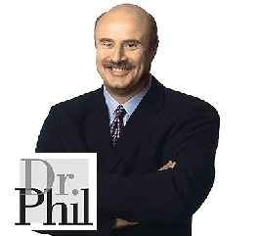
Press Release Summary: With a case of extreme obesity slowly killing a man, Dr. Phil has called upon Bistro MD and Dr. Caroline Cederquist M.D., the developer of the diet with hopes that her expertise and her medical delivery diet can offer critical help to the situation.
Press Release Body: With a case of extreme obesity slowly killing a man, Dr. Phil has called upon Bistro MD and Dr. Caroline Cederquist M.D., the developer of the diet with hopes that her expertise and her medical delivery diet can offer critical help to the situation.
On the show, which air yesterday, January 29, Dr. Phil employs his popular team approach, and he’ll have input from his usual posse of medical experts for Kevin, who at age 44 has reached the stunning weight of 715 pounds. But faced with a weight problem that extreme, not just any doctor has the depth of experience to offer meaningful help.
So Dr. Phil called in BistroMD and Dr. Cederquist, a board-certified family and bariatric physician who has at the core of her treatment a focus not on extreme diets or radical regimens, but on addressing the metabolic irregularities that develop in overweight people from a few pounds overweight to hundreds of pounds.
“Kevin is disabled and virtually homebound,” says Dr. Cederquist. “He has gained 300 pounds in the past five years. He suffers from diabetes and severe sleep and breathing difficulties. Problems with his joints and his sheer mass make it almost impossible for him to move around, and as a result, he scarcely leaves his bed, let alone his house. Getting him from home to the Dr. Phil studios was a major undertaking.”
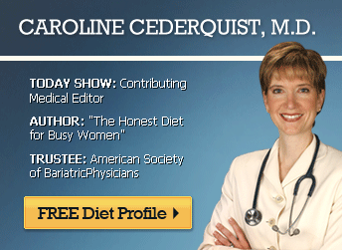
Dr. Cederquist said Kevin had been rejected for weight-loss surgeries because the medical conditions related to his obesity make him too high-risk as a candidate for surgery. He has sunk into a depression over his worsening situation, and resorts to eating for comfort, further worsening his conditions—and his despair.
“These are often people who have been successful at everything else in their lives, and they cannot understand why their efforts to lose even 20 pounds are so futile,” she says. “But for them, it’s just not as simple as eat less, burn more. Losing weight is not just about eating less of the wrong things; it is about eating more of the right things.”
Because Kevin’s high-risk status prevents him from pursuing bariatric surgery, Dr. Phil’s staff assessed a number of options for Kevin, and ultimately, Dr. Phil asked Dr. Cederquist to help with Kevin’s case. She had developed a home diet delivery program that specifically addresses both the practical and metabolic problems most people as well as Kevin must overcome. The home delivery diet, called BistroMD, is a home-delivered diet that Dr. Cederquist developed..
The gourmet foods in the BistroMD diet will help Kevin deal with both the practical and the medical challenges he faces. The meals are portion-controlled and designed to preserve lean muscle tissue as the dieter loses body fat. Because they are low in glycemic load, the foods also tend to reduce the sugar and carb cravings that lead so many to abandon their dieting attempts.
While Kevin is an extreme example, his metabolic abnormalities are common and are becoming more so. Currently 70.8% of men and 66.2% of women in the U.S. are overweight. The vast majority of overweight people develop metabolic abnormalities as they gain. But with the right nutritional program is the underlying principle of the Bistro MD diet. The macronutrients of the diet include adequate lean protein spread throughout the day, controlled portions of complex carbohydrates and the right amount of “good” fats. www.BistroMD.com
About Bistro MD
Dr. Cederquist set about creating fresh pre-packaged working with professional chefs to develop recipes for dishes both delicious and metabolically sound. Today BistroMD meals are prepared using cutting-edge food preparation technology to assure an optimal balance of preparation convenience, correct nutrient content, and peak dining enjoyment. Affordable dining plans are fresh frozen, delivered right to the dieter’s home weekly, eliminates the need for grocery shopping and takes just minutes from package to plate. Bistro MD at www.BistroMD.com or 1-866-401-3438.
Web Site: http://www.bistromd.com
Contact Details: Bistro MD
Attn: Dick Bruno
1575 Pine Ridge Road #19
Naples, FL 34109
239-352-0281

