New Inventory of Baby Gifts & Newborn Baby Gift Sets
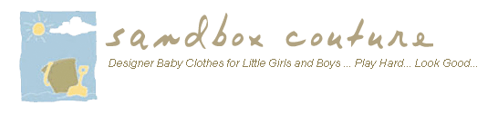

Released on: January 26, 2008, 6:19 pm
Press Release Author: Sam Brown/ Sandbox Couture
Industry: Retail
Press Release Summary: Arrival of Latest Styles & Top Picks for Baby Showers, Birthdays and Newborn Gifts
Press Release Body: Rancho Santa Margarita – CA January 29, 2008 – Sandbox Couture, a popular online children's boutique retailer of baby gifts, baby clothes and unique baby gift ideas today announced its added new items to its season inventory, offering customers the latest fashions and attractive gift ideas.
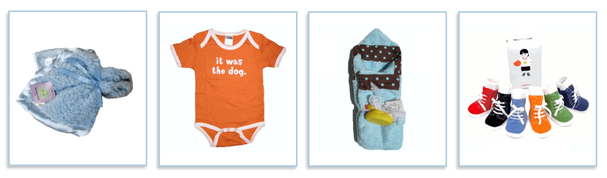
The company features top picks from the Trumpette Baby Socks line such as the Trumpette Jenny Golf, Trumpette Johnny Golf plus the Cowboy and Cowgirl baby socks, ideal baby gift sets or stand alone gifts. SandboxCouture.com has a huge selection of designer gifts, perfect for baby shower gifts, birthday gifts, newborn celebrations or other special occasions. The site features high end and fashionable brands including, Trumpette Baby Socks, Patricia Ann Designs, Urban Smalls, Inky Dink plus a host of other designer baby gifts and baby gift sets.
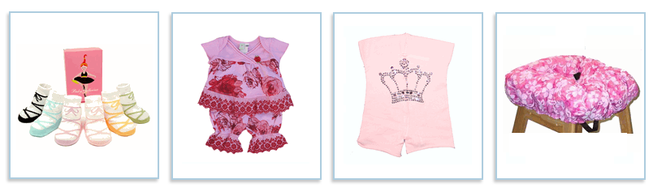
"With the addition of our newest items, we continue to offer eye-catching gift wrapping as well as the option for gift messages making shopping for unique baby gifts effortless," stated Sam Brown, spokesperson for Sandbox Couture. "Whether shopping for boys or girls, newborns or toddlers, we have wonderful baby gifts and baby gift sets available and most items ship same day, giving shoppers a convenient, fast and reliable source for stylish ideas and chic baby gifts," Brown concluded.
SandboxCouture.com has been selling baby clothes, designer children's clothes and baby gifts since 2005. As a designer boutique, the online retailer strives to offer the latest trends in baby clothes and baby gift ideas. By providing unique and fashion forward gift ideas, both the giver and the recipient can enjoy their gift in style. From couture baby gifts, baby clothes and the most sought-after baby gift sets, SandboxCouture.com provides the top fashions and must have brand names in baby clothes, children's clothes and baby gifts. For more information, please visit http://www.sandboxcouture.com.
About Sandbox Couture
Sandbox Couture is an online children's boutique retailer, providing designer baby clothes, designer children's clothing and unique baby gifts. The company takes pride in hand selecting products from top designers, thereby ensuring quality and contemporary style. Sandbox Couture’s philanthropic contributions and socially conscious business practices are at the forefront of the company’s ideals and corporate culture. Founded in 2005, Sandbox Couture is privately held and headquartered in Rancho Santa Margarita, CA. For information about Sandbox Couture, please visit the company's web site at http://www.SandboxCouture.com
Web Site: http://www.sandboxcouture.com/baby-gift.html
Contact Details: Press Contact
Sam Brown
949-459-2505
pr@sandboxcouture.com

