3CX Phone System v7.1 Delivers Personal Phone Assistant for ALL


Released on: April 23, 2009, 4:47 am
Author: 3CX Ltd
Industry: Telecommunications
New 3CX Assistant for 3CX Phone System offers one-click call transfer, call parking, call divert, presence and more
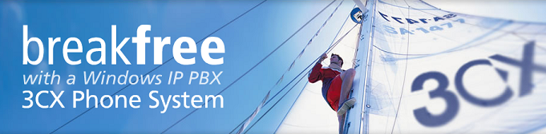
London, UK – 22 April 2009 - 3CX today announced the availability of 3CX Phone System for Windows 7.1, which includes 3CX Assistant, a desktop utility that drastically improves phone usability and user productivity. 3CX Assistant offers extension users an easy way to transfer, divert, launch or park calls - via “drag and drop” rather then via a cryptic phone interface. In addition 3CX Assistant offers unified communications features such as extension status (presence) of other users and Call Queue information.
“3CX Assistant makes it much easier to take advantage of Phone System features” said Nick Galea, 3CX CEO. “Rather then learn cryptic phone dial codes, users can use their mouse and a familiar Windows GUI”.
Works with ANY phone including ANALOG phones.
3CX Assistant works in tandem with an existing phone, be it an IP phone, a soft phone, or even an ANALOG phone and thus delivers the benefits of VoIP and Unified communications to all. In fact, re-using analog phones via low cost FXS gateways is now more attractive and can drastically lower the investment cost in a new VoIP Phone System.
3CX Assistant features at a glance
- Transfer, Divert or Park calls with a mouse click or via “Drag and Drop”
- See status of other extensions and avoid “Telephone Tag”
- Notification upon receiving a new voice mail message
- View number of callers in a Queue
- Pick – up calls waiting in the Queue
- See which agents are logged on or on a call
- Login/Logout to/from Queues
- Set user status to away/available
3CX Phone System 7.1 has an easy to use rights system that allows granular configuration of who can see what call information and perform which call operations.
Other 7.1 features
Besides the 3CX Assistant, 3CX Phone System has gained several other important features:
- A new built in Call Reporter with many new reports including Call Queue and Agent Reports
- A CDR service that can output Call Data Records in any format
- Improved default security and installation
- Compatibility with Microsoft Small Business Server 2003 and 2008
About 3CX
3CX is an international developer of telecommunications software, headquartered in Europe with offices in the UK, USA, Germany, Cyprus, Malta, Australia and Hong Kong. It is a Microsoft Gold Certified partner and is backed by an experienced management and development team. Its product, 3CX Phone System for Windows, developed specifically for the SMB (small & medium business) market, has earned Windows Server 2003 Certification and has received numerous awards, including The Windowsnetworking.com Gold Award, the Communications Solutions 2007 Award, the Windows IT Pro magazine 2008 Editor’s Best Award and a Best Buy Award by Computer Shopper Magazine, all in recognition to the company’s commitment to innovation and quality. 3CX maintains a global presence with localized information available in various languages. For more information, visit www.3cx.com.
Contact Details: 3CX Ltd
Block B, Office 303
Engomi Business Center
1, 28th October Street
2414 Nicosia, Cyprus
Tel: +357 22 444032
Fax: +357 22 444033
Email: mc@3cx.com
Website: http://www.3cx.com

