Naugatuck Glass continues under New Flag: FLABEG Technical Glass U.S. Corporation

Released on: April 29, 2009, 4:07 am
Author: Ch. Radwan
Industry: Energy
Nuremberg / Naugatuck, 28th April 2009. With a change of name to FLABEG Technical Glass U.S. Corp. the acquisition of Naugatuck Glass, Connecticut, initiated in mid-2008, is now complete. By this move FLABEG has expanded its solar portfolio with a focus on thin glass technology for solar applications.
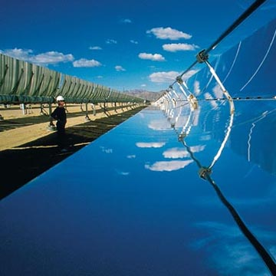
In the field of machining and finishing of thin glass with strengths of 0.95 mm, Naugatuck Glass acquired a leading position. And now FLABEG is building on this experience to develop strategically ist future orientation as a leading supplier in the field of concentrating solar thermal power plants (CSP). Additionally, in this context, it is also pressing ahead with the development of lead-and copper-free protection and coating systems for solar energy applications.
“Even for parabolic-reflector power stations thinner glass units are interesting. The thinner the glass, the higher the degree of reflection,” explains Axel Buchholz, CEO of the FLABEG Group. Thus FLABEG is once again manifesting its role as an experienced and innovative partner for plant operators.
FLABEG, founded in 1882, is an independent company with ten manufacturing facilities in Europe, America and Asia. FLABEG is active in the commercial sectors of automotive mirrors, solar glass mirrors and technical glass, specializing in all processes of glass finishing, and sets technological standard in terms of the company‘s core competencies - bending and coating.
Mirror components, bending and the application of optical and functional layers also rank among the core competencies of FLABEG Technical Glass U.S. Corp., (formerly Naugatuck Glass, founded in 1927) so that FLABEG now virtually covers the spectrum of flat glass processing.
Contact Details:
FLABEG Holding GmbH
Waldaustr. 13
D-90441 Nürnberg
www.flabeg.com
Press contact:
Kerstin Kötter
Phone: +49 (0)911 96456 248
Fax: +49 (0)911 96456 450
E-Mail: kerstin.koetter@flabeg.com

