New Website SteroidSources.com Not Afraid To Tackle Big Issues
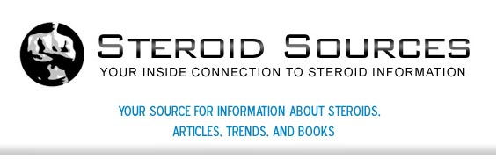

Released on: April 29, 2009, 3:28 am
Author: Steroidsources.com
Industry: Healthcare
St. Petersburg, Florida, April, 2009 -- SteroidSources.com offers visitors the latest news and educational articles on the topic of steroids. The site is the premier online destination for anyone interested in learning about the legal use of steroids, health issues, steroid scandals, bodybuilding, anabolic steroid products, and more.

A comprehensive source of information, the website is one of the best places on the Internet to access up-to-date news headlines, videos, and books on steroids and related topics. SteroidSources.com also provides trustworthy, in-depth reviews of steroids for sale, and a forum that allows visitors to share information, experiences, and views on steroids online.
Steroids have been big news in recent years, but it can be difficult to sort through all the information available online. Whether you want to read about steroid use in baseball, football, bodybuilding, boxing, or the Olympics, Steroid Sources has plenty of resources available on its website for free. Visitors can peruse a wide variety of different news items and articles to become more informed about the many issues surrounding the use - and abuse - of anabolic steroids.
The news blog is updated daily with new content, and it's easy to find information related to a whole host of performance-enhancing drugs, including dianabol, anadrol, deca-durabolin, winstrol-v, and sustanon. All information on the website is for educational purposes, and is meant to inform consumers about the variety of options available on the market.
Steroid Sources also provides information on HGH (human growth hormone) and where to buy anabolic steroids once a doctor's prescription has been obtained. The website has everything the individual needs to make informed decisions regarding the proper use of steroid products, whether they are purchased online or elsewhere.
Many people wrongly assume that buying steroids is not an easy task. Fortunately, there are many hassle-free ways to purchase anabolic steroids. With the right information and resources, it's fairly simple to assess the different choices available to consumers and make appropriate decisions for your health goals.
For more information about anabolic steroids, contact Steroid Sources or visit http://www.steroidsources.com.
About SteroidSources.com: SteroidSources.com is a popular website that offers visitors interesting and relevant information, resources, and news on the topic of buy anabolic steroids. The sitealso provides a forum where like-minded individuals can meet to discuss issues like buying steroids, obtain advice, andswap personal experiences and stories.
Contact Details: http://steroidsources.com/
SS, Inc.
22nd Avenue
P. O. Box 530007
St. Petersburg, FL 33747

