Revised Accounting System RFI/RFP Checklists released by Axia


Released on: April 6, 2009, 8:35 am
Author: Axia Consulting Ltd
Industry: Software
Accounting System RFI/RFP Checklists from Axia, provide a fast, accurate and structured approach to specifying user needs/systems requirements and creating RFI’s, RFP’s for new Accounting software.
The Checklists have been successfully used by many organisations, of all sizes, worldwide. Now, as at April 2009, they have been revised, updated and also extended, to include sections for vendor responses and for scoring the responses - to facilitate an impartial software / vendor response evaluation.
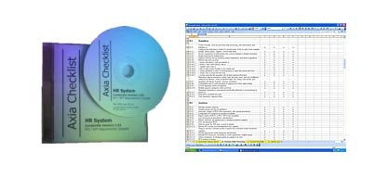
The revised Accounting Checklists have been carefully researched and list 3450+ Accounting functions, 500+ business analysis and overview criteria, and 950+ system wide, operations, technology and support criteria.
The Checklists are totally impartial and independent of software packages and vendors. They are written in MS Excel for complete flexibility and tailoring to users precise needs.
Richard Starling, Axia’s Director explains “The enhanced multi-purpose Accounting Checklists make selecting Accounting systems even faster and more effective, because they provide a pre-built standard format for specifying requirements, creating RFI’s RFP’s and then evaluating and scoring vendor responses”.
Three versions - Enterprise, Corporate and SME (for different accounting requirements and different size organisations) - are available directly from Axia’s website, by immediate download, email or CD.
For further information, visit: www.axia-consulting.co.uk/html/accounting.html
Contact Details: Axia Consulting Ltd
Spiere House, 17 New Road Avenue, Chatham, Kent ME4 6BA, United Kingdom
Phone: +44 1634 848894
Fax: +44 01634 868894
Email: info@axia-consulting.co.uk
Web: www.axia-consulting.co.uk

