Smile South Florida Website Goes Multilingual (Cosmetic Dentist in Florida)
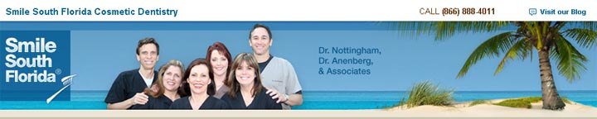

Released on: April 2, 2009, 7:30 am
Author: Smile South Florida Cosmetic Dentistry
Industry: Healthcare
Smile South Florida is announcing that it has added language translation on its website.
Smile South Florida's main focus for its website is the ease and usability of which its clients can find what they need. With so many of our patients coming from abroad, Smile South Florida needed to be able to speak to these patients needs too. "We are seeing such a large number of international patients," says Heather, who is the New Patient Coordinator for Smile South Florida Cosmetic Dentistry. "Many patients want to take a trip to south Florida for vacation/holiday, and get their cosmetic dental work done at the same time, or receive treatment while they come here for a business trip," Heather mentioned. "In all cases, people are more than willing to travel a great distance when it comes to their long term dental health and the aesthetics of their smile."
To accommodate a broad range of clientele, the dental practice has added a new feature on our website called the 'language bar.' This language bar can be found on the left hand side in the navigation area of our website. It can be easily spotted as a bar that consists of several colorful flags. Each flag is representative of the language of origin for that specific country. When you click on each flag, the website will automatically change to display that language. For example, if you click on the flag of France, the website will be translated into French for you. Currently, the dental practice website can be translated into French, Spanish, Portuguese, German, and Italian.
This makes it much easier for someone to read about the office, the services, and obtain contact information. Having a tool like this is very useful because it reaches across nations. Smile South Florida is helping patients everyday from all over the world achieve the smile of their dreams!
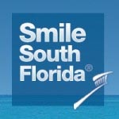
About Smile South Florida Cosmetic Dentistry
The cosmetic dentists at Smile South Florida Cosmetic Dentistryhave offices in Broward County and West Palm Beach and provide patients Boca Raton Dentistry, Fort Lauderdale Dentistry and Miami Dentistry. The dentists specialize in dental aesthetics including porcelain veneers, dental implants, extreme makeoversInvisalign, and sedati on dentistry.
About Dr. Charles Nottingham South Florida Dentist & Miami Cosmetic Dentist, Charles Nottingham, D.D.S., Fellow in the Academy of General Dentistry, is an internationally and nationally renowned cosmetic dentist. He has been creating dazzling, healthy smiles for his patients since 1974. Contact Details: 7401 N. University Drive, Suite 207 • Tamarac, FL 33321 • 954.721.6950 • 954.726.4292 7301-A W. Palmetto Park Rd. #303-C • Boca Raton, FL 33433 • 561.347.7757

