The Key to Tomorrow’s Health Help and Healing through the Teachings of Bruno Groening An international panel of physicians reports about a special way of healing on the spiritual path
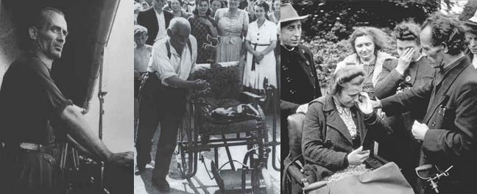

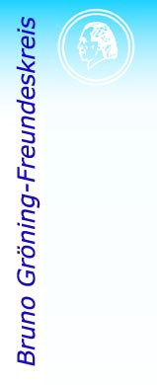
Released on: April 13, 2009, 2:18 am
Author: Kathy Mason, Mason Works, LLC
Industry: Healthcare
An extraordinary series of lectures will be held in Fairfax, VA (near Washington, DC) and Los Angeles, CA in May, 2009. Seven Medical specialists from four countries will report about a free special way of healing for everyone. Medical doctors, veterinarians and psychologists from Europe, America, Asia, Australia and Africa have formed the Medical Scientific Group of Specialists (MWF). The task of this group, which belongs to the Bruno Groening Circle of Friends, is to record and verify healings the spiritual way. A compilation of more than 200 concise healing reports can be found on our web site:www.bruno-groening.org/english/ under the link Healings.
The international panel of physicians includes:
G. Blaettner, M.D., Germany,Board Cert. ENT
M. Galante, M.D., USA
L. Colizoli, M.D., USA, Board Cert. Psych.
K. Winchester, M.D.,USA Board Cert., Opthal.
Prof. G. Beketova, M.D., Ph.D., Ukraine, Board Cert. Pediatrics, Prof.Univ. of Kiev
R. Friewald, M.D., D.V.M., Germany
F. Gringinger, M.D., D.O., Austria, Board Cert. Family Prac.
R. Leo, USA
They will speak about their experiences on the following dates.
Saturday, May 2, 2009 at 3 – 7 pm
(incl. 30 min. break):
George Mason University,
Fairfax Campus
Lecture Hall, Room 1
4400 University Drive
Fairfax, VA 22030
Contact: Mrs. Heidi Gewehr at 571-313-0267 or h.gewehr@web.de
*Sunday, May 3, 2009 ~ 3 -7 pm
(incl. 30 min. break)*:
Anderson School of Management, UCLA
(park in structure 4)
Korn Convocation Hall - C Building
110 Westwood Plaza
Los Angeles, CA 90095
Contact: Chris Runge at 323.394.4691 or chrismwf.info@yahoo.com
During these lectures, physicians will talk about persons who have experienced healing and freedom from long lasting, severe and chronic diseases in a miraculous way. Medical documents will be presented; the experts will explain the intricacies of a superior healing power that has been widely forgotten in modern medicine. The teachings of Bruno Groening (1906-1959), who became world famous due to extraordinary healings in the fifties, are taken as a basis for the lectures. Bruno Groening said time and again: “There is no incurable – God is the greatest physician”. He spoke about a higher power that he called the healing stream, life power or divine energy. This power is abundantly available for everyone. The knowledge about how to make use of this power is passed on free of charge in the worldwide non-profit, volunteer based organization of the Bruno Groening Circle of Friends.
The work of the MWF is supported by some well-known people in the United States, e.g. Dr. Christiane Northrup and Dr. Carl Simonton. Link to information online: http://www.bruno-groening.org/english/lectures2009.htm
######
Contact Details: Kathy Mason, kathy@mason-works.com
PR for North America, BG Circle of Friends
http://www.bruno-groening.org/english/lectures2009.htm
303-527-2978
720-938-2536 cell

