npower encourages Brits to get inventive to beat the crunch
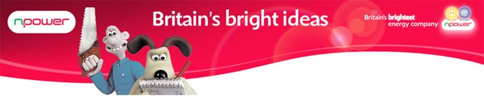

Released on: April 21, 2009, 5:14 am
Author: Nick McHugh
Industry: Energy
npower has conducted a new study which reveals that 40% of adults are convinced they have come up with a great idea or invention that they hope could make them rich.

The study, commissioned by leading energy company npower to launch Britains Bright Ideas, a nationwide search for new energy saving inventions and ideas, also revealed that over one in four men (26%) now regularly devise new creations. A further 40% of all adults surveyed were spurred on to try inventing due the current economic climate.
npower has linked up with Wallace & Gromit in its new adverts, and it seems the British public shares the animated duo's have-a-go approach to innovation. But, while Wallace is caught out by his inefficient boiler in the latest ad, 36% of the British public are intent on concocting contraptions that reduce household bills, saving both energy and money.
The findings also suggest pillow talk is a thing of the past, with almost half (46%) of budding British inventors generally devising their ideas in bed, while a further 16% of men have their light bulb moment on the loo.
Adults are more aware than ever of the importance of energy efficiency in protecting the planet and their pockets, with 82% agreeing that new energy saving ideas should receive more support. In response to the research, npower is urging enterprising adults to act on their inspiration by entering their top energy saving devices, gadgets and clever thoughts into the Britain's Bright Ideas competition.
Notes to Editors:
All figures, unless otherwise stated, are from YouGov Plc. Total online sample size was 2224 adults. Fieldwork was undertaken 9th - 14th April 2009. The figures have been weighted and are representative of all GB adults (aged 18+).
About npower
npower is one of the UK's largest electricity suppliers and has 6.6 million customer accounts across the UK. npower sponsors the 2009 npower Ashes Series in England, Women's Test Series, the Twenty20 Cup and Village Cup.
RWE npower has been awarded the prestigious CommunityMark from Business in the Community (BITC). npower is the only utility business, amongst 21 other companies in the UK, to receive this accolade. The CommunityMark is a new BITC standard which has been created to recognise companies that are good investors in local communities and who have brought about real and positive changes.
The npower Active programme, which is run in partnership with the English Federation of Disability Sport, has been awarded a prestigious 'Silver Big Tick' by Business in the Community.
Contact Details:
PR Contact:
Nick McHugh
npower
Oak House
WR4 9FP
Worcester
07795 354 628
www.npower.com/brightideas

