Anabolic Steroids For Sale At Steroid Sources, Trusted Website To Buy Steroids Online
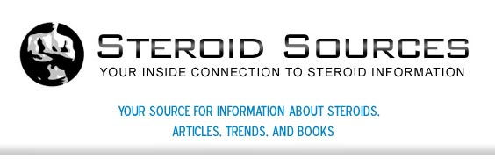

Released on: May 14, 2009, 6:19 am
Author: steroidsources.com
Industry: Healthcare
May, 2009: Finding steroids online does not have to be a daunting task. Finding steroids online should include extensive research on the type of steroid one may want to use, how to properly and safely use them and where to buy them from. Steroids Sources is an
experienced and trusted website where one can buy anabolic steroids from.
Looking to buy steroids online is easy with Steroid Sources! While Steroid Sources is a great resource to buy anabolic steroids, it's important to consult a health care professional before choosing to use steroids. Because of various reactions to steroids as well as a large number of diseases or ailments a user may have, it's important that a doctor is consulted. While Steroid Sources provides comprehensive information, they neither are not health care professional nor certified to give health advice.
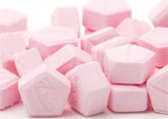
Steroid Sources professionals can be asked other non health-related questions however. In order to make the best decision for someone's particular lifestyle or health situation, great care should be taken before looking to buy steroids online. Another important decision regarding the process is choosing which steroids to use and buy.
Anabolic steroids are also available. When looking to buy anabolic steroids, careful research of specific products and their ingredients should be carefully read. It's important to also remember and follow the proper drug amount, frequency and duration of steroids to help to deter possible side effects.
It's also important to realize other potential hazards when looking to buy anabolic steroids:
Word of caution regarding laws that may exist when purchasing anabolic steroids online. The restriction of purchasing for adults over the age of 18. The potential for abuse and how to ensure that this does not occur when using anabolic steroids.
Ultimately, the individuals that choose to purchase anabolic steroids online needs to make sure the website they choose, Steroids Sources, takes pride in their products and protecting their customers. Whatever the type of steroid one chooses to purchase, whether natural or synthetic (manmade), good quality steroids are a must when choosing to use them.
Whether using them for medicinal purposes or for athletic performance reasons, all steroids have a potential to damage one's health if not used properly. A health care professional can answer more health-related questions regarding steroids. Steroid Sources is more of a source of general steroid information and where to buy steroids online safely.
For more information on Steroid Sources, visit their official website at www.steroidsources.com. Their legal steroids and buy anabolic steroids page will give comprehensive information on how to safely purchase steroids online. Visit them today!
Contact Details: http://steroidsources.com/
SS, Inc.
22nd Avenue
P. O. Box 530007
St. Petersburg, FL 33747

