Combined Cycle Performance Analysis Announces A Presence In Asia
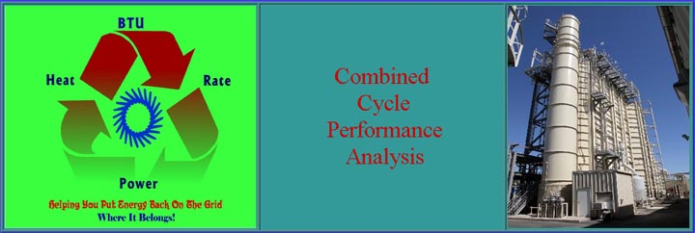
Released on: May 4, 2009, 3:14 am
Author: COMBINED CYCLE PERFORMANCE ANALYSIS/Tom Hesly
Industry: Energy
COMBINED CYCLE PERFORMANCE ANALYSIS can work more closely with its clients in Asia. Located in Central Thailand, makes it very convenient to all countries in Asia.
The company provides consulting to the Combined Cycle power industry. Services include Plant Performance Evaluations, training, and custom consulting.
With fuel prices near record levels, it is imperative that plant owners and operators focus on Plant Performance. Combined Cycle Performance Analysis will assist you in keeping your company's plant operating at it's best. With a combination of a plant evaluation and a dedicated on site training session, your company can be assured that the Plant Performance is optimum.
Browse through our website and contact us with any of your special plant needs.
Contact Details: 72 Moo 7, Sapanhin
Nongmamong, Chainat 17120 Thailand
Phone: In Asia +66 895-285-241
email: asiasales@lowermyheatrate.com
website: www.LowerMyHeatRate.com

