Drug Rehab Mountainside Treatment Center Indentifies Common Misconceptions Regarding Underlying Medical Risks Associated With Substance Abuse And Alcoholism

Released on: May 29, 2009, 7:50 am
Author: Drug Rehab, Mountainside, Treatment Center
Industry: Healthcare
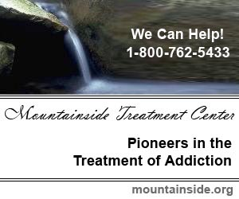
Drug Rehab and Alcohol Treatment Center Mountainside announced has identified common misconceptions regarding underlying and peripheral medical risks associated with drug addiction and alcohol abuse. Despite the volumes of information on these matters, there is a seemingly large body of people unaware of the extent of the danger that active addiction or alcoholism poses.
Recent studies have shown that besides the immediate and obvious health risks of being addicted to alcohol or drugs, there are other medical problems that can arise as a direct or indirect result of a person’s substance abuse. It is common knowledge that an alcoholic is in danger of cirrhosis of the liver, heart disease and pancreatitis. These are the obvious ailments. There is also the risk for making poor decisions such as getting behind the wheel while intoxicated. This decision has the power to not only affect the substance abusers health but also endangers the lives of others. What is not as apparent are the risks associated with things that a person may do when drunk that they would never do while sober; such as being sexually promiscuous which can lead to conditions like HIV, AIDS as well as a list of other possibilities. It is by addressing these issues that the substance abuse treatment center helps the individual suffering from addiction to recover and become educated about the drug and alcohol rehabilitation process.
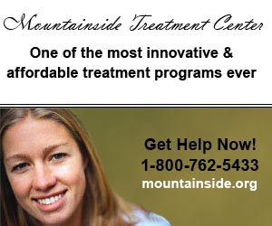
People who abuse illicit drugs are also at risk. For example, people who snort powder cocaine are at risk for hepatitis. The risk comes from sharing different pieces of paraphernalia associated with snorting, such as straws or rolled up paper money. There is also the heroin user who puts themselves at risk by sharing needles, cotton, water or “cooking” devices. There is also the risk for IV drug users for bacterial infections. Bacterial infections are responsible for a large portion of hospitalizations of IV drug users. The list of possibilities can go on and on. The point is that besides the apparent risks there are countless other possibilities that can change a person’s life and perspective on life.
Drug Rehab is the best chance that someone has at regaining control of their life and getting in control of their health. If you believe that someone you know is an alcoholic or may be addicted to drugs, the time is now to get them the help they need. Mountainside Drug Rehab and Alcohol Treatment Center has been helping people recover and educating them on the dangers of addiction for over 12 years.
It's licensed and credentialed counselors and clinical staff includes an Advanced Nurse Practitioner and Psychiatric Services available by specialists in drug addiction and alcoholism treatment. The highly capable addiction treatment team is dedicated to providing compassionate and quality alcohol and drug treatment. In these hard economic times - Mountainside Drug Rehab is there to help. Please contact the below number or visit it's Treatment Center website at Drug Rehab Center (www.mountainside.org/drug-rehab).
If you or someone you love is in need of treatment please contact us at: 800-762-5433
Contact Details: Drug Rehab - Mountainside
PO Box 717
Canaan, CT 06018
800-762-5433
http://www.mountainside.org/drug-rehab

