Mobile Awareness Announces SenseStat™ SE Obstacle Detection Sensor System Version


Released on: June 8, 2009, 5:30 am
Author: Mobile Awareness, LLC
Industry: Transportation & Logistics
[CLEVELAND, OH - June 4, 2009] Mobile Awareness, LLC, a provider of leading-edge transportation safety products today announced the SE (Sensor Enhancement) version of their SenseStat™ Obstacle Detection Sensor System family – the pioneering brand for preventing backing accidents on commercial vehicles.
SenseStat is an innovative Obstacle Detection Sensor System that simultaneously monitors 4-zones at the rear of a vehicle indicating the area closest to an object. It is extremely accurate (within one inch), highly affordable and intended for use on Commercial, Off-Road, Lift Truck and Construction Vehicles. The SenseStat SE version is a new design improvement which maximizes protection of the sensors, while providing greater mounting flexibility and reliability. These features found on the SE version are further enhanced by a full 3 year limited warranty.
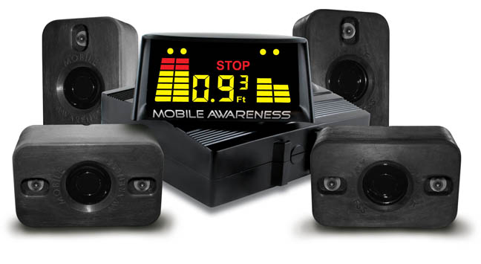
Installation of SenseStat SE is easy and adaptable to most vehicle configurations, helping to assure the highest performance in rear blind spot detection. The ruggedized mount maximizes performance in harsh environments enhancing both durability and sensor protection. The SenseStat SE can be mounted directly to the vehicle vertically or horizontally, providing a level plane for optimum sensor positioning.
“Mobile Awareness continues to see an increasing demand among commercial fleets for more cost effective and easily installed safety systems” says Brandon Stotsenburg, Director of Sales & Marketing at Mobile Awareness. “To that end, we continue to focus on new product development that offers a lower total cost of ownership such as the SenseStat SE.”
The current models available in the SE version are the Wireless (MA-ODSS-4M17W-SE), Wired Truck & Trailer (MA-ODSS-4M17TT-SE) and the Wired Box Truck (MA-ODSS--4M17BT-SE). Common among them are the ability to simultaneously monitors four (4) zones in real-time, an LED display which indicates the direction or location of an obstacle or person, display blanking until reverse gear is engaged and a unique stop-line adjustment feature. All systems are easily installed in less than 1-hour on most vehicles and include a laminated User Guide (safety instruction card) for easy driver education & reference.
Stotsenburg concludes, “With an estimated installed cost of less than $500 on most vehicles, SenseStat SE provides an impressive ROI for organizations who wish to significantly reduce costs and enhance safety in backing environments.”
About Mobile Awareness
Cleveland, Ohio based Mobile Awareness, LLC™ designs and markets leading-edge, affordable transportation safety products. The company provides integrated accident prevention solutions for commercial transportation professionals with its VisionStat™ Wired & Wireless Vehicle Camera Systems, TireStat™ Tire Pressure Monitoring Systems (TPMS) and SenseStat™ Wired & Wireless Obstacle Detection Sensor Systems. For more information, please contact Mobile Awareness, Toll Free: 866-653-5036 or visit www.MobileAwareness.com
Mobile Awareness…Reducing the Total Cost of Safety™
###
Contact: Brandon Stotsenburg, Director of Sales & Marketing
Phone: 866-653-5036
bvs@mobileawareness.com

