eFUSION Announced eWiFi Reached 1.5 Million Downloads And V2.0 Is Going To Submit For Apple's Review


Released on: February 17, 2010, 8:48 am
Author: eFUSION Co., Ltd.
Industry: Telecommunications
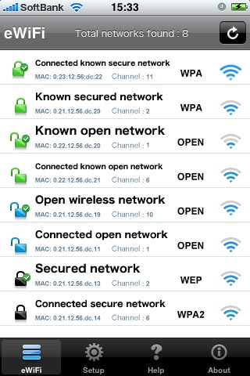
eFUSION announced that the most popular utility application in app store eWiFi downloaded by 1.5 million users. Recently 10,0000 users downloading eWiFi every day. eFUSION also going to submit a new version 2.0 to app store on this month including new features demanded by a vast number of iPhone and iPod touch users by e-mail, twitter, forums and several social networks.
eWiFi is wifi access point finder utility application. It is a great utility application for iPhone and iPod touch user who wants to access faster internet through WiFi and for travelers who loves free open WiFi to get internet access during travel. Also the new version of eWiFi will care about expert user who want to connect home and office secure WiFi network automatically with first priority. eWiFi downloaded by 1.5 million users with in 4 and half months from the release date.
This application attracted several medias attention from all over the world including USA. Some mentionable ranking of eWiFi are listed below:
#2 Top Free application in USA - February 2010
#2 Top Free application in Japan - October 2009
#1 Top Free application in Italy - January 2010
#1 Top Free application in Nederland - January 2010.
Every day eFUSION getting many requests for eWiFi features update from iPhone and iPod touch users. eFusion planed and already have completed the development of new version of eWiFi 2.0. The new version included new features as majority users asked by email and comments in app store. The new version will submit for review to Apple Inc by eFUSION on Wednesday, February 17. Hope Apple will consider about their iPhone, iPod touch and eWiFi users. eWiFi users will get the new version on their hand as early as Apple will complete their review process. It will bring a change on wifi utility application.
Key Features:
• Access Point Scan
o Scan for OPEN, SECURED(WEP/WPA/WPA2) and Ad-hoc wireless networks
o Sort wireless networks list according to Known Secured, Known Open, Open, Secured, Ad-hoc and network signal strength.
o Display signal strength bar of each network.
o Customize networks display list.
• Auto Scan
o Auto wireless access point scan support.
o Auto scan repeat time setup.
o Scan access points by shaking your device.
• Auto Connect
o Auto connect support.
o Minimum signal strength setup for auto connect.
o Automatically launch Safari/Mail or Exit from eWiFi after connect to wireless network.
o Sound notification during successful auto connection.
• Credentials
o Ability to connect with secure network using credential when network not hidden.
o Ability to save password of SECURED network for farther login.
• Known/Ignore List
o Automatically add access point to the known list when successful connect.
o Ignore a network when want to avoid.
o Functions to remove networks from Known and Ignore list.
• Others
o Last login time display for known networks.
o Wonderful user interface with help in every point.
Pricing: The new version of eWiFi will be free too.
URL: http://www.efusion.co.jp/en/news/2010/20100217-1.html
Inquiry concerning eWiFi:
Sohel Taslim
eFusion Co., Ltd
Tel:048-420-9704 FAX:048-240-5655 E-mail:info@efusion.co.jp
Company Overview:
Name: eFUSION Co., Ltd.
Established: May 25, 1995
Activities: Website development and maintanace, iPhone aplication development
http://www.efusion.co.jp/en
Contact Details: Sohel Taslim
eFusion Co., Ltd
Tel:048-420-9704 FAX:048-240-5655 E-mail:info@efusion.co.jp

~~~~~

Press release distributed via EPR Network (http://express-press-release.net/submit-press-release.php)

